Open Dumps
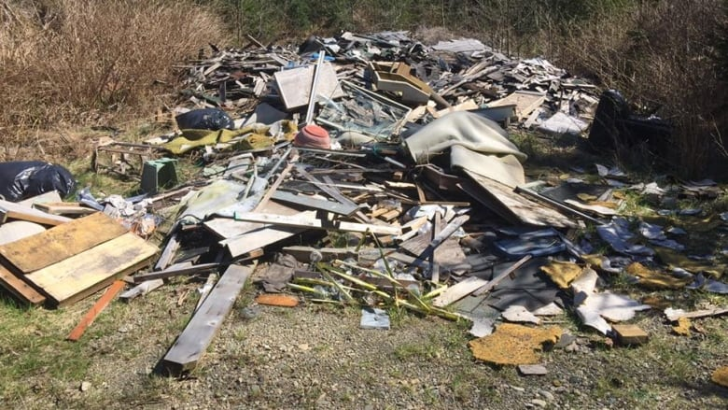
Photo from CBC NEWS: Illegal Dump Site

Abandoned piles of trash, including bags of household garbage and yard waste, appliances, old barrels, used tires, and construction and demolition debris including shingles, dimensional lumber, pipes, and other materials can threaten the health of both humans and wildlife. Called Open Dumps, these sites can be found throughout Illinois – Jumbled at the bottom of ravines, in empty lots and pastures, and along the roadside. An open dump is an improper waste disposal site and should not be confused with a sanitary landfill. Sanitary landfills must obtain local siting approval and an Illinois environmental protection agency permit before operating and must abide by strict environmental regulations.
Open Dumps pose the following threats:
- Explosion
- Fire
- Inhalation of toxic gases
- Bodily injury to children playing in or around the dump site
- Disease carried by mosquitos, flies, and rodents.
- Surface water contamination
- Groundwater contamination
- Damage to plants and wildlife
Open dumps also create a public nuisance, divert land from more productive uses and depress the value of surrounding land.
Open dumping is prohibited by law!
Not only is causing or allowing open dumping illegal, but such action may result in substantial penalties. The following seven conditions at a dump site can result in the issuance of a petty offense citation, administrative citation or the filing of misdemeanor or felony criminal charges:
- Litter
- Scavenging
- Open burning including tires, shingles, and roofing materials but not containerized household refuse burned at the location it is generated as long as neighbors are not affected.
- Placement of waste in standing or flowing water
- Promoting an increase of disease carrying organisms
- Standing or flowing discharge from the dumpsite
- Burning of houses, buildings or other structures without a permit issued by the Illinois Environmental Protection Agency.

The petty offense Citation Carries a Minimum $50 fine for a first offense and $100 or greater fine for subsequent violations. The assessment fee for the Clerk’s office is around $100 bringing the total cost of the first ticket to around $150 and the second violation to $200. A citation can be issued for each condition during every inspection until the violation is resolved. In addition, every day that a condition persists counts as a separate violation. An administrative citation carries a $500 penalty and is also issued for each condition during every inspection. In addition to the petty offense and administrative citation, the county can pursue criminal charges and confiscate profits and vehicles that result from, or are used to create an illegal dump. Criminal charges can range from misdemeanors to felonies and carry a maximum fine of $25000.
Citizens are encouraged to report open dumping to the solid waste department or local law enforcement authorities first. These departments have the advantage of being close to the scene of the crime and can initiate an investigation or enforcement action almost immediately. The solid waste management department are concerned about open dumping and can:
- Respond immediately to complaints
- Promptly investigate to determine the source of the open dumping
- Require an immediate cleanup of the area
- Refer the case to the states attorney for prosecution
- Patrol the problem area
The Christian county solid waste management department has a delegation agreement with the Illinois environmental protection Agency. The agreement allows the solid waste department to enforce the environmental protection act within the confines of Christian county.
The landowner is responsible for all open dumping that occurs on his/her property – even id the landowner is neither the dumper nor has any knowledge of the dump site. The language of the law “no person shall cause or allow the open dumping of any waste,” has been interpreted by courts to include the passive conduct (failure to post “No dumping” Signs, failure to put up barriers to access, etc.) of the landowner. Essentially, the owner has a duty to prevent pollution. The dumper, if different from the landowner, is also liable for causing open dumping and also subject to enforcement action. The generator of a waste can be held responsible too, if the person hired to dispose of the waste does so illegally.
Of course, the Solid Waste Department is concerned most with those individuals who create dumpsites. Cooperation between landowners and the Solid Waste Department is essential to prosecution of these individuals.
It is imperative that property owners take measures to protect themselves against dumping and subsequent pollution.
You can deter Dumpers by:
- Putting up barriers (Locked cables and gates) to prevent physical access to any portion of the property.
- Posting warning signs such as no trespassing or No Dumping
- Cleaning up Dump sites immediately so as not to encourage others to dump.
- Notifying the solid waste department and local law enforcement as well as keeping a log book. Record the date, time and a description of what is dumped and which authorities you notified each time you found signs of dumping.
- Ask local law enforcement or the solid waste department to patrol the problem area more frequently.
- Alerting adjoining property owners of the open dumping problem and enlisting their help in a watch and prevention program.
- Setting up cameras of entry and exit points on your property with solar charge ability for low maintenance.

Some of the materials found in open dumps are banned from landfills. Others require disposal in a special waste landfill which charges higher disposal fees.
Acceptable Disposal options for commonly dumped materials
Garbage
Most garbage disposal companies comply with the environmental laws, however, not all of these companies are on the “up and up”. Commercially hauled garbage is sometimes found in open dumps. A reason for this may be that the disreputable hauler finds that he or she can make a bigger profit by dumping the garbage rather than paying for the disposal fees to the landfill. Regardless of whether the generator of the garbage has contracted with the hauler, he or she still remains responsible for the garbage if it is illegally disposed.
As a waste generator, you can take actions to reduce the risk or liability by:
- Contracting with a reputable waste hauler
- Always asking for a receipt of disposal
- Reducing, reusing, and recycling as much of your daily garbage as possible and
- Choosing durable, long lasting goods over less expensive, disposable goods.
Landscape waste
Landscape waste has been banned from landfills since July 1 1991. There are many landscape waste disposal options:
- Burn when allowed by local ordinance
- Construct an on site well maintained compost bin.
- Mulch grass clippings, leaves, and wood chips for lawn application

Used Tires
Whole tires were banned from landfills on July 1, 1994. More than 240 million used tires are scrapped per year. Consequently, many are not disposed of properly. Used tire dumps have become havens for disease carrying mosquitos. Also, open burning of tires causes’ air and water pollution. Tires should be stored indoors or in such a manner where they are not able to deteriorate in extreme elements or accumulate water as to aid in breeding disease vectors.
- Participate in used tire collections via the department when available.
- Allow your tire retailer to dispose of your used tires for you.
- Buy “new” quality retreaded tires when available.
White Goods
Items that fall under the classification of “white goods” include: refrigerators, freezers, ranges, water heaters, air conditioners, humidifiers and other similar domestic and commercial large appliances. Components of white goods (Mercury switches, chlorofluorocarbon (CFC) refrigerant gas and polychlorinated biphenyl’s (PCBs) were banned from landfills on July I, 1994.
The landfills that are permitted to receive white goods are those that participate in the industrial material exchange service and those that have an IEPA approved operating plan and permit for white good disposal. Five Oaks Recycling and Disposal Facility, which is the only landfill in Christian County, does not accept white goods for disposal.
Rather than landfilling the appliance, you could make arrangements to have it hauled to a scrap yard where the metal can be reclaimed.
Lead Acid Batteries
Lead acid batteries were banned from landfills as of September 1, 1990.
- Exchange acid batteries for new when purchasing a battery.
- Sell used car batteries to a salvage yard
Motor Oil
Motor oil was banned from landfills as of July 1, 1996.
- Save the used oil in a leak proof container. Some service stations accept used oil.
- Have your oil changed at a service station that recycles and properly disposes of used oil.
- Dumping used oil in the street, alley, on the ground, down the sewer or using it for dust control can subject you to substantial criminal penalties.
Household Hazardous Waste
Household Hazardous waste collections give citizens an opportunity to safely rid their homes of unwanted hazardous waste for free. The following items are not banned from landfills but are harmful to the environment if not disposed of properly.
Weed killer Drain cleaner Antifreeze Paint Pesticides Cleaners Gasoline
Paint thinners Insect/rodent poisons Kerosene Asbestos Corrosives
The household Hazardous Waste Program is only open to individuals, not industry, business or agricultural operations. For more information, contact our office at 217-287-2334.
Household Paint & Paint Products
These items are collected in household Hazardous Waste collections.
- Use all of the paint by applying additional coats
- Carefully calculate or estimate the amount of paint you will need to complete your project
- Donate usable leftover paint to local churches, housing authorities, or service organizations.
- Drop off old paint, especially those containing oil or other hazardous elements, at household hazardous waste collections.
Paint thinners, turpentine, mineral spirits and other solvents must NOT be poured down the drain. Instead, these steps should be followed
- Paint thinners, turpentine, mineral spirits sit in a closed container until paint particles settle out.
- Pour off the liquid and reuse
- Mix residue with unused cat litter, let dry and dispose with your household waste at an IEPA permitted landfill.
Industrial Waste
Appropriate disposal methods for industrial waste are dependent on the characteristics of the waste.
Industrial waste can be hazardous or non-hazardous. Examples of industrial waste include: pickling liquors, cutting oils, chemical catalysts and etching acids. It is the responsibility of the generator of industrial waste (hazardous and non-hazardous) to contract with a licenses waste hauler and disposal company and to keep records on the quantity and types of waste generated and disposed. The generator must keep in mind that liability for the industrial waste does not end when the waste hauler drives away.

Demolition Debris
Landfills accept both clean and non-clean construction or demolition debris. Clean fill is debris that is broken concrete without protruding metal bars, bricks, rocks, stone, reclaimed asphalt pavement or uncontaminated dirt or sand. When you contract to have construction or demolition debris disposed of, make sure the cost of proper disposal is specified in your contractors bid. As a precaution, get receipts from your contractor.

